P032 - Garden Fleet 03 Actions

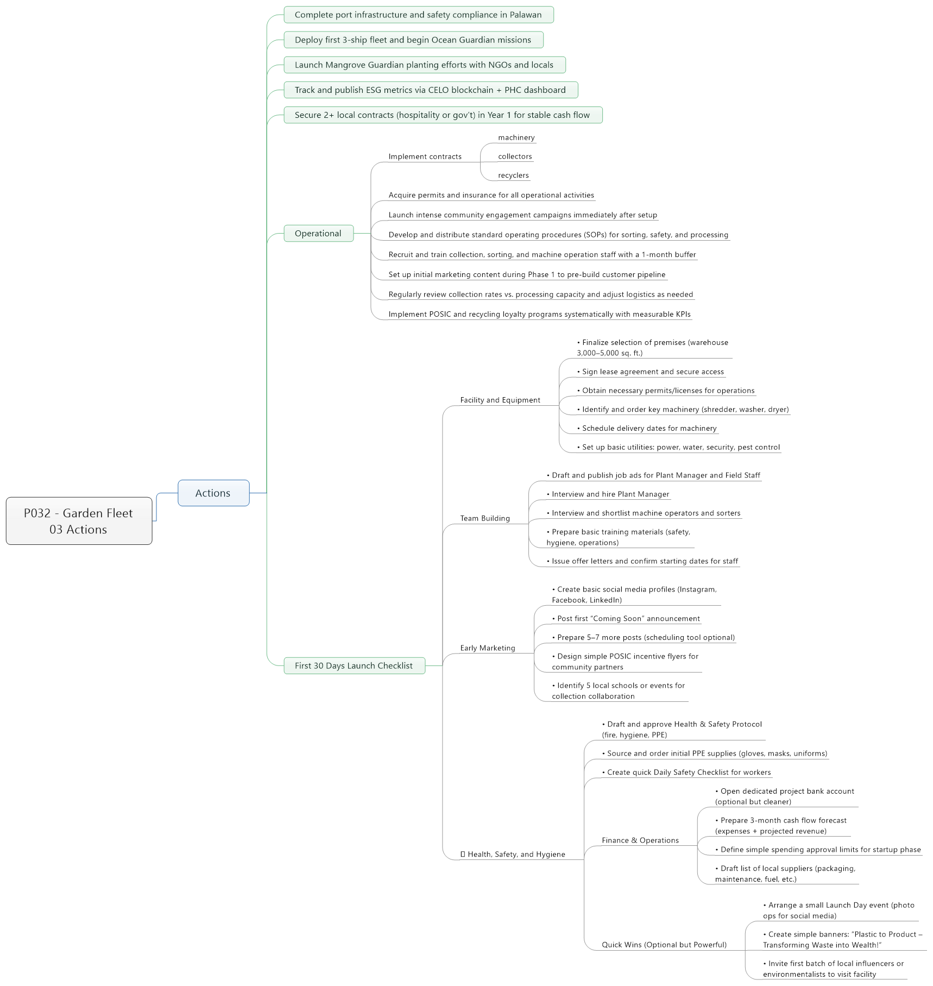

1. Actions
   1. Complete port infrastructure and safety compliance in Palawan
   2. Deploy first 3-ship fleet and begin Ocean Guardian missions
   3. Launch Mangrove Guardian planting efforts with NGOs and locals
   4. Track and publish ESG metrics via CELO blockchain + PHC dashboard
   5. Secure 2+ local contracts (hospitality or gov’t) in Year 1 for stable cash flow
   6. Operational
      1. Implement contracts
         * machinery
         * collectors
         * recyclers
      2. Acquire permits and insurance for all operational activities
      3. Launch intense community engagement campaigns immediately after setup
      4. Develop and distribute standard operating procedures (SOPs) for sorting, safety, and processing
      5. Recruit and train collection, sorting, and machine operation staff with a 1-month buffer
      6. Set up initial marketing content during Phase 1 to pre-build customer pipeline
      7. Regularly review collection rates vs. processing capacity and adjust logistics as needed
      8. Implement POSIC and recycling loyalty programs systematically with measurable KPIs
   7. First 30 Days Launch Checklist
      1. Facility and Equipment
         * • Finalize selection of premises (warehouse 3,000–5,000 sq. ft.)
         * • Sign lease agreement and secure access
         * • Obtain necessary permits/licenses for operations
         * • Identify and order key machinery (shredder, washer, dryer)
         * • Schedule delivery dates for machinery
         * • Set up basic utilities: power, water, security, pest control
      2. Team Building
         * • Draft and publish job ads for Plant Manager and Field Staff
         * • Interview and hire Plant Manager
         * • Interview and shortlist machine operators and sorters
         * • Prepare basic training materials (safety, hygiene, operations)
         * • Issue offer letters and confirm starting dates for staff
      3. Early Marketing
         * • Create basic social media profiles (Instagram, Facebook, LinkedIn)
         * • Post first “Coming Soon” announcement
         * • Prepare 5–7 more posts (scheduling tool optional)
         * • Design simple POSIC incentive flyers for community partners
         * • Identify 5 local schools or events for collection collaboration
      4. ️ Health, Safety, and Hygiene
         * • Draft and approve Health & Safety Protocol (fire, hygiene, PPE)
         * • Source and order initial PPE supplies (gloves, masks, uniforms)
         * • Create quick Daily Safety Checklist for workers
         * Finance & Operations
           + • Open dedicated project bank account (optional but cleaner)
           + • Prepare 3-month cash flow forecast (expenses + projected revenue)
           + • Define simple spending approval limits for startup phase
           + • Draft list of local suppliers (packaging, maintenance, fuel, etc.)
         * Quick Wins (Optional but Powerful)
           + • Arrange a small Launch Day event (photo ops for social media)
           + • Create simple banners: “Plastic to Product – Transforming Waste into Wealth!”
           + • Invite first batch of local influencers or environmentalists to visit facility