P032 - Garden Fleet 02 Concerns

1. 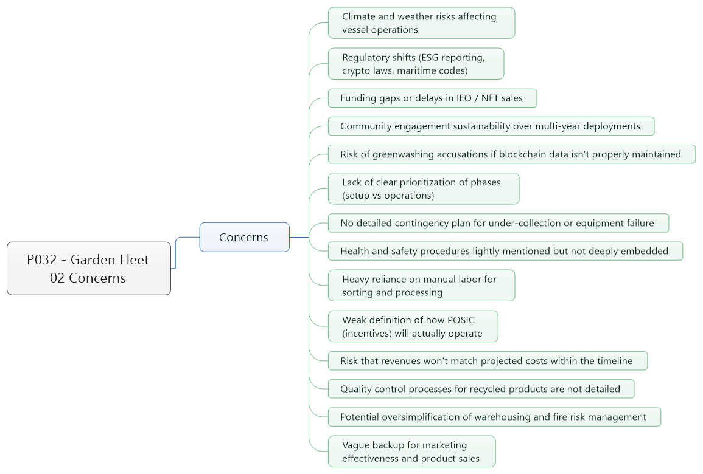Concerns
   1. Climate and weather risks affecting vessel operations
   2. Regulatory shifts (ESG reporting, crypto laws, maritime codes)
   3. Funding gaps or delays in IEO / NFT sales
   4. Community engagement sustainability over multi-year deployments
   5. Risk of greenwashing accusations if blockchain data isn’t properly maintained
   6. Lack of clear prioritization of phases (setup vs operations)
   7. No detailed contingency plan for under-collection or equipment failure
   8. Health and safety procedures lightly mentioned but not deeply embedded
   9. Heavy reliance on manual labor for sorting and processing
   10. Weak definition of how POSIC (incentives) will actually operate
   11. Risk that revenues won't match projected costs within the timeline
   12. Quality control processes for recycled products are not detailed
   13. Potential oversimplification of warehousing and fire risk management
   14. Vague backup for marketing effectiveness and product sales