P032 - Garden Fleet 07 Deliverables

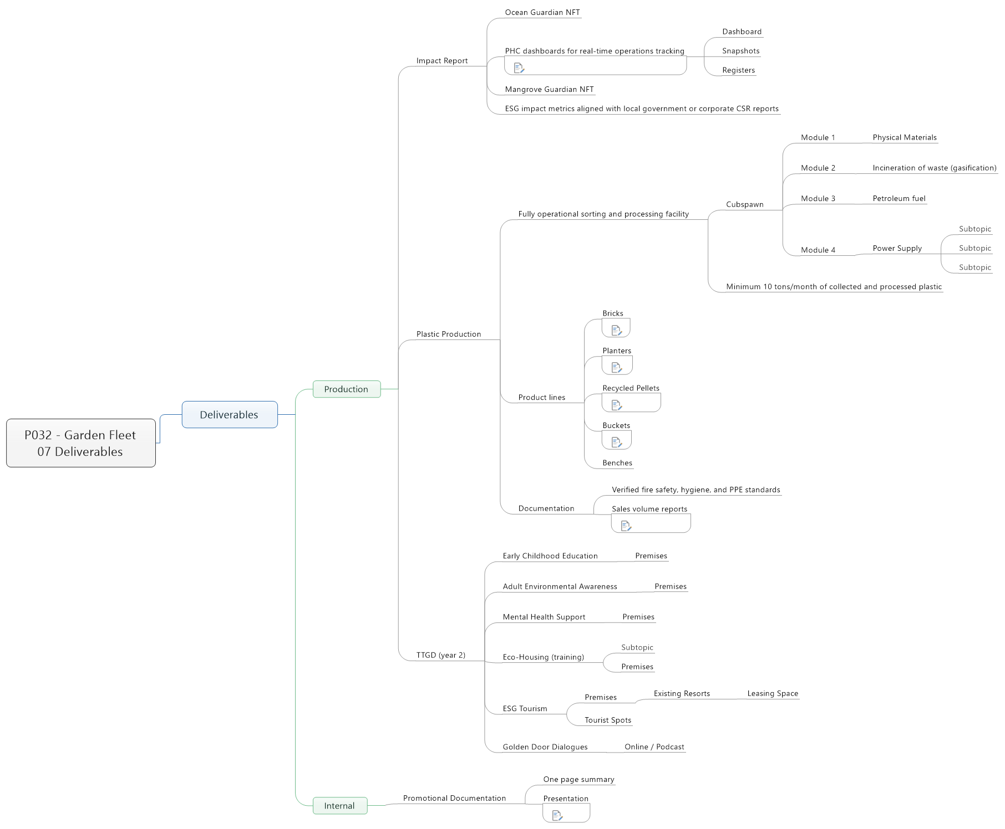

1. Deliverables
   1. Production
      1. Impact Report
         * Ocean Guardian NFT
         * PHC dashboards for real-time operations tracking

dw to fill

* + - * + Dashboard
        + Snapshots
        + Registers
      * Mangrove Guardian NFT
      * ESG impact metrics aligned with local government or corporate CSR reports
    1. Plastic Production
       - Fully operational sorting and processing facility
         * Cubspawn

Module 1

Physical Materials

Module 2

Incineration of waste (gasification)

Module 3

Petroleum fuel

Module 4

Power Supply

Subtopic

Subtopic

Subtopic

* + - * + Minimum 10 tons/month of collected and processed plastic
      * Product lines
        + Bricks

how many

how big

use

* + - * + Planters

size

Number

* + - * + Recycled Pellets

Product of the recycling plant

* + - * + Buckets

Trash collection

* + - * + Benches
      * Documentation
        + Verified fire safety, hygiene, and PPE standards
        + Sales volume reports

hitting ₹4 lakh/month revenue target by Month 6

* + 1. TTGD (year 2)
       - Early Childhood Education
         * Premises
       - Adult Environmental Awareness
         * Premises
       - Mental Health Support
         * Premises
       - Eco-Housing (training)
         * Subtopic
         * Premises
       - ESG Tourism
         * Premises

Existing Resorts

Leasing Space

* + - * + Tourist Spots
      * Golden Door Dialogues
        + Online / Podcast
  1. Internal
     1. Promotional Documentation
        + One page summary
        + Presentation

where on google drive