P032 - Garden Fleet 06 Events

1. 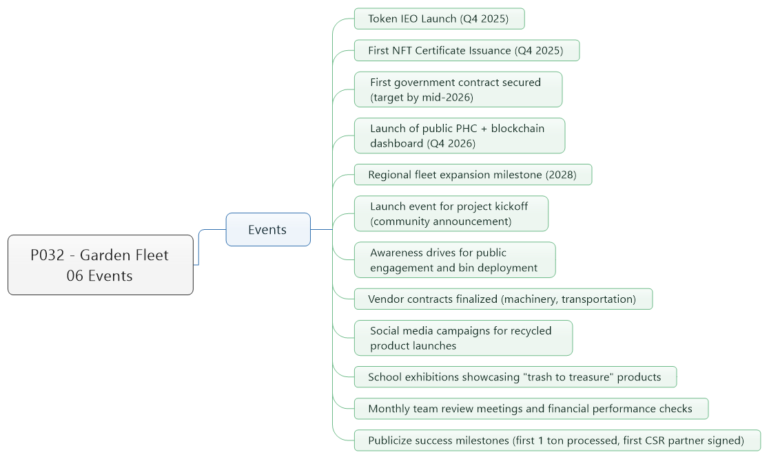Events
   1. Token IEO Launch (Q4 2025)
   2. First NFT Certificate Issuance (Q4 2025)
   3. First government contract secured (target by mid-2026)
   4. Launch of public PHC + blockchain dashboard (Q4 2026)
   5. Regional fleet expansion milestone (2028)
   6. Launch event for project kickoff (community announcement)
   7. Awareness drives for public engagement and bin deployment
   8. Vendor contracts finalized (machinery, transportation)
   9. Social media campaigns for recycled product launches
   10. School exhibitions showcasing "trash to treasure" products
   11. Monthly team review meetings and financial performance checks
   12. Publicize success milestones (first 1 ton processed, first CSR partner signed)