P032 - Garden Fleet 04 Locations

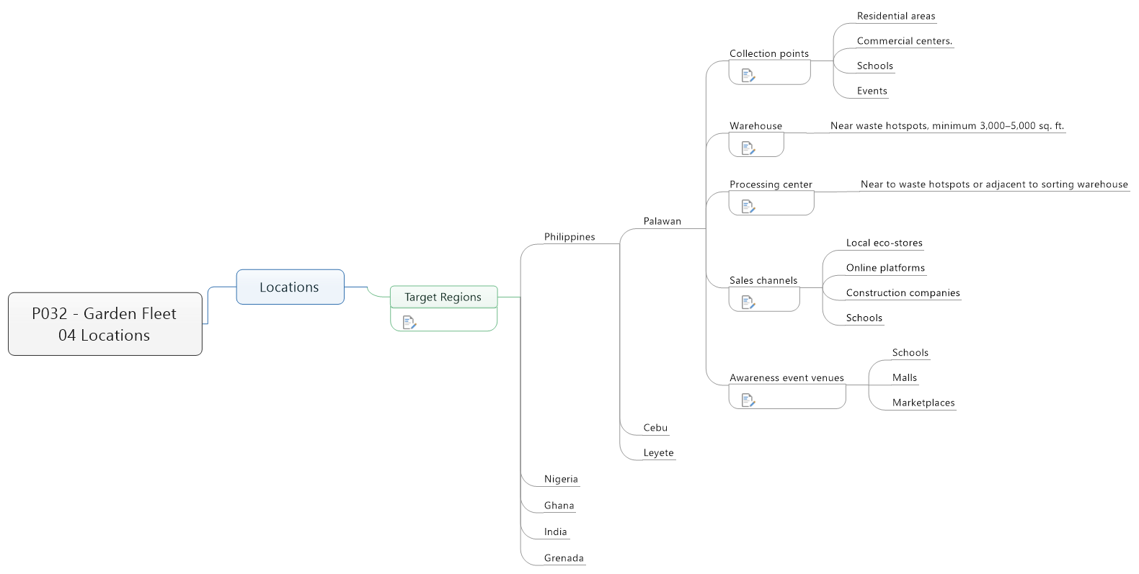

1. Locations
   1. Target Regions

Philippines

 Other high-pollution coasts

  Cebu

  Leyete

Nigeria

Ghana

India

Grenada

* + 1. Philippines
       - Palawan
         * Collection points

Residential areas

Commercial centers.

Schools

Events

Residential areas

Commercial centers.

Schools

Events

* + - * + Warehouse

Near waste hotspots, minimum 3,000–5,000 sq. ft.

Near waste hotspots, minimum 3,000–5,000 sq. ft.

* + - * + Processing center

Near to waste hotspots or adjacent to sorting warehouse

Near to waste hotspots or adjacent to sorting warehouse

* + - * + Sales channels

Local eco-stores

Online platforms

Construction companies

Schools

Local eco-stores

Online platforms

Construction companies

Schools

* + - * + Awareness event venues

Schools

Malls

Marketplaces

Schools

Malls

Marketplaces

* + - * Cebu
      * Leyete
    1. Nigeria
    2. Ghana
    3. India
    4. Grenada