P032 - Garden Fleet 05 People

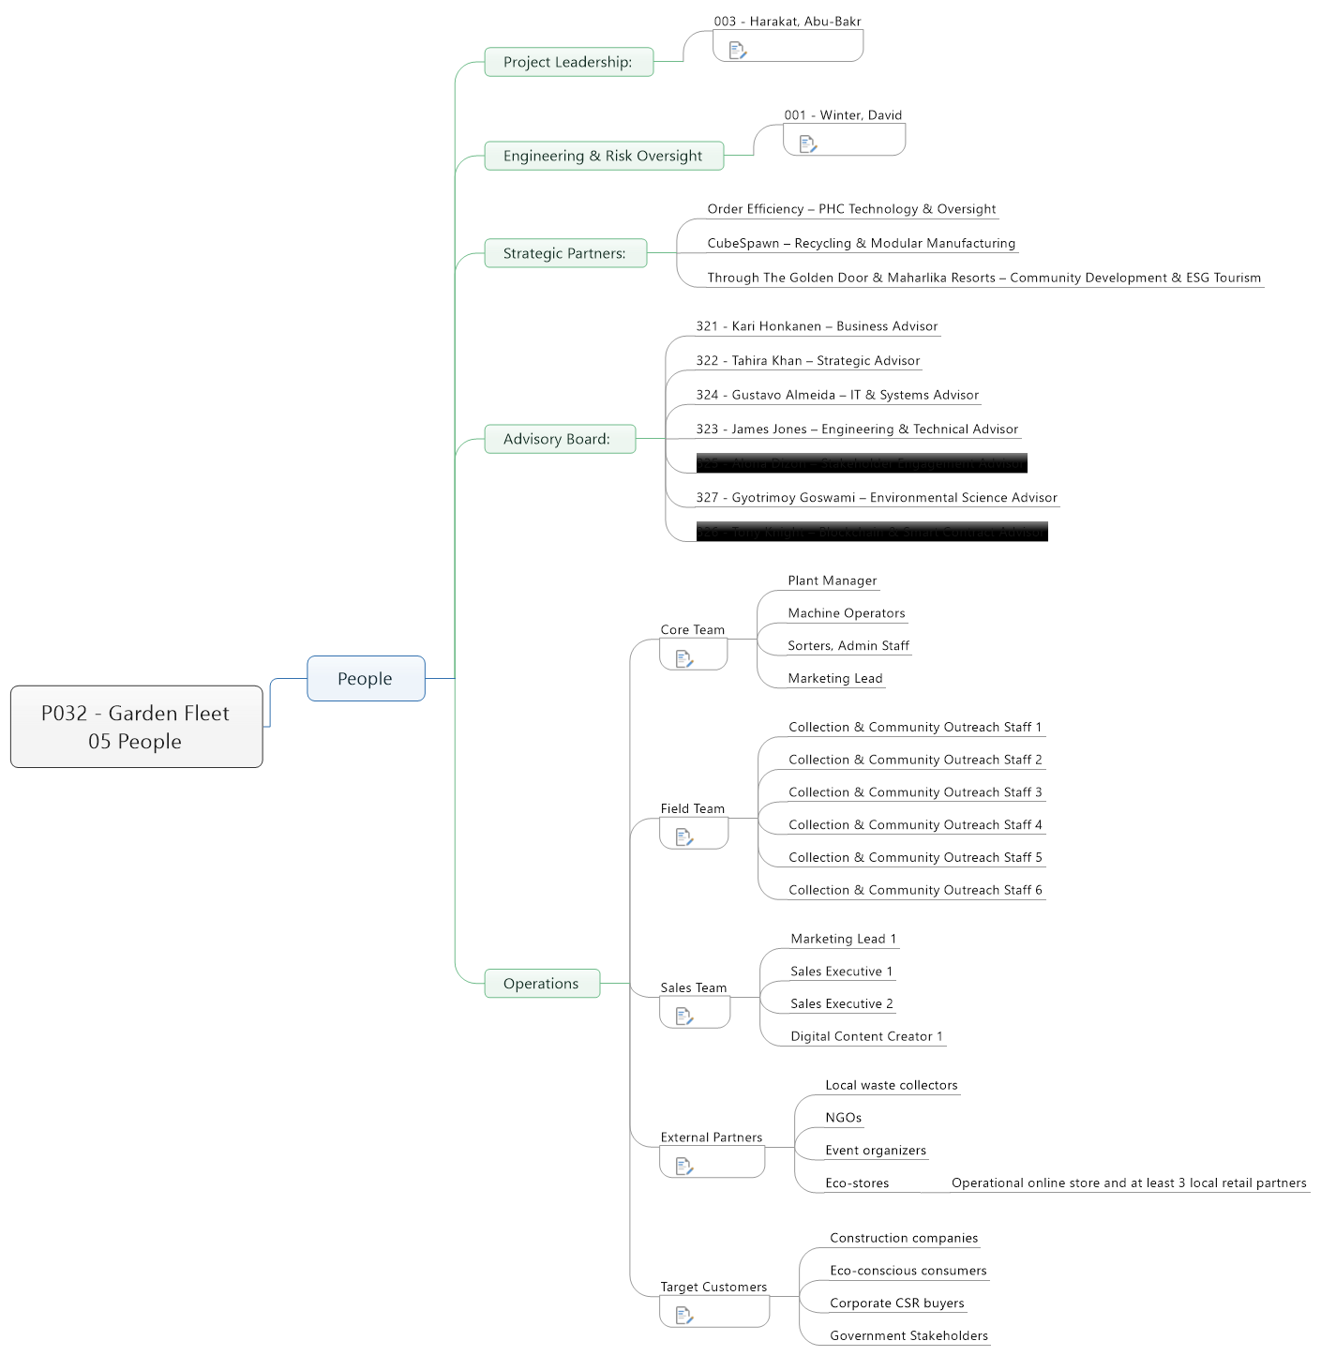

1. People
   1. Project Leadership:
      1. 003 - Harakat, Abu-Bakr

Founder of Garden Fleet, ESG Consultant, and certified PMP. Oversees strategic vision, stakeholder engagement, and program delivery.

* 1. Engineering & Risk Oversight
     1. 001 - Winter, David

Senior Infrastructure Engineer with 30+ years of experience. Leads PHC implementation, project assurance, and fleet safety protocols.

* 1. Strategic Partners:
     1. Order Efficiency – PHC Technology & Oversight
     2. CubeSpawn – Recycling & Modular Manufacturing
     3. Through The Golden Door & Maharlika Resorts – Community Development & ESG Tourism
  2. Advisory Board:
     1. 321 - Kari Honkanen – Business Advisor
     2. 322 - Tahira Khan – Strategic Advisor
     3. 324 - Gustavo Almeida – IT & Systems Advisor
     4. 323 - James Jones – Engineering & Technical Advisor
     5. 325 - Alona Dizon – Stakeholder Engagement Advisor
     6. 327 - Gyotrimoy Goswami – Environmental Science Advisor
     7. 326 - Tony Knight – Blockchain & Smart Contract Advisor
  3. Operations
     1. Core Team

Plant Manager

Machine Operators

Sorters, Admin Staff

Marketing Lead

* + - * Plant Manager
      * Machine Operators
      * Sorters, Admin Staff
      * Marketing Lead
    1. Field Team

Collection & Community Outreach Staff 1

Collection & Community Outreach Staff 2

Collection & Community Outreach Staff 3

Collection & Community Outreach Staff 4

Collection & Community Outreach Staff 5

Collection & Community Outreach Staff 6

* + - * Collection & Community Outreach Staff 1
      * Collection & Community Outreach Staff 2
      * Collection & Community Outreach Staff 3
      * Collection & Community Outreach Staff 4
      * Collection & Community Outreach Staff 5
      * Collection & Community Outreach Staff 6
    1. Sales Team

Marketing Lead 1

Sales Executive 1

Sales Executive 2

Digital Content Creator 1

* + - * Marketing Lead 1
      * Sales Executive 1
      * Sales Executive 2
      * Digital Content Creator 1
    1. External Partners

Local waste collectors

NGOs

Event organizers

Eco-stores

* + - * Local waste collectors
      * NGOs
      * Event organizers
      * Eco-stores
        + Operational online store and at least 3 local retail partners
    1. Target Customers

Construction companies

Eco-conscious consumers

Corporate CSR buyers

* + - * Construction companies
      * Eco-conscious consumers
      * Corporate CSR buyers
      * Government Stakeholders