P032 - Garden Fleet 01 Schedule

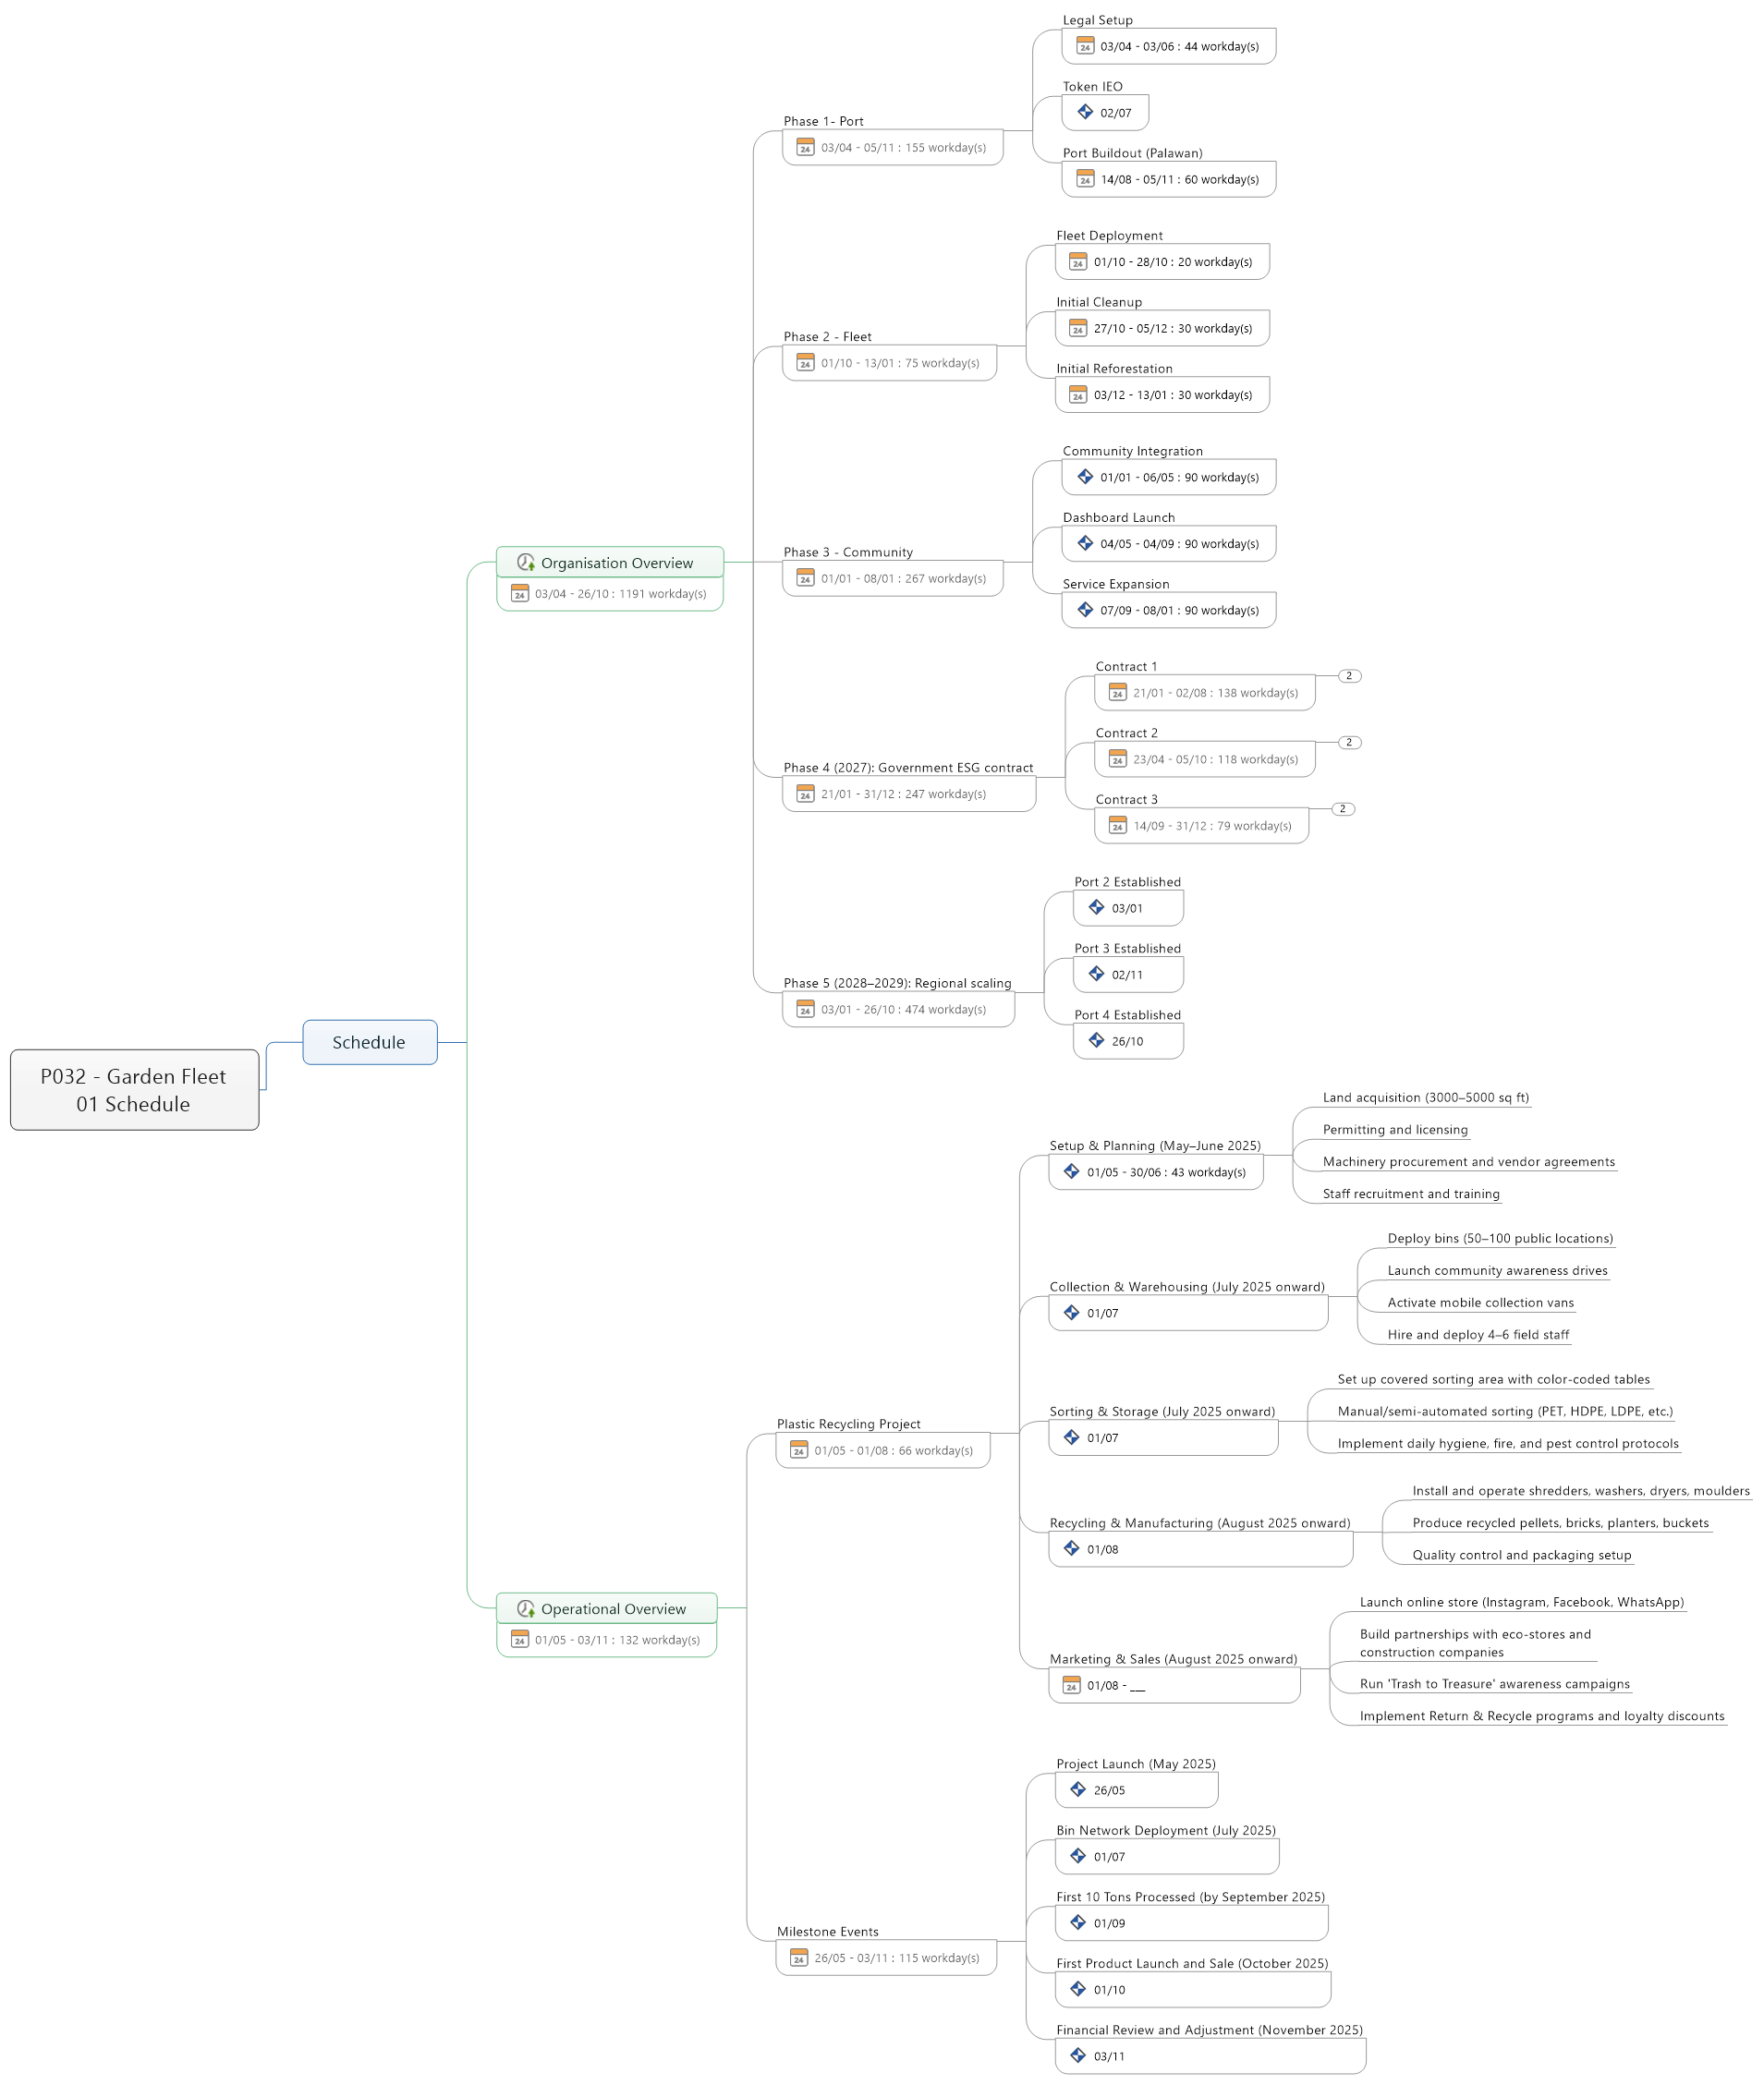

1. Schedule
   1. Organisation Overview
      1. Phase 1- Port
         * Legal Setup
         * Token IEO
         * Port Buildout (Palawan)
      2. Phase 2 - Fleet
         * Fleet Deployment
         * Initial Cleanup
         * Initial Reforestation
      3. Phase 3 - Community
         * Community Integration
         * Dashboard Launch
         * Service Expansion
      4. Phase 4 (2027): Government ESG contract
         * Contract 1
           + Onboarding
           + Auditing
         * Contract 2
           + Onboarding
           + Auditing
         * Contract 3
           + Onboarding
           + Auditing
      5. Phase 5 (2028–2029): Regional scaling
         * Port 2 Established
         * Port 3 Established
         * Port 4 Established
   2. Operational Overview
      1. Plastic Recycling Project
         * Setup & Planning (May–June 2025)
           + Land acquisition (3000–5000 sq ft)
           + Permitting and licensing
           + Machinery procurement and vendor agreements
           + Staff recruitment and training
         * Collection & Warehousing (July 2025 onward)
           + Deploy bins (50–100 public locations)
           + Launch community awareness drives
           + Activate mobile collection vans
           + Hire and deploy 4–6 field staff
         * Sorting & Storage (July 2025 onward)
           + Set up covered sorting area with color-coded tables
           + Manual/semi-automated sorting (PET, HDPE, LDPE, etc.)
           + Implement daily hygiene, fire, and pest control protocols
         * Recycling & Manufacturing (August 2025 onward)
           + Install and operate shredders, washers, dryers, moulders
           + Produce recycled pellets, bricks, planters, buckets
           + Quality control and packaging setup
         * Marketing & Sales (August 2025 onward)
           + Launch online store (Instagram, Facebook, WhatsApp)
           + Build partnerships with eco-stores and construction companies
           + Run 'Trash to Treasure' awareness campaigns
           + Implement Return & Recycle programs and loyalty discounts
      2. Milestone Events
         * Project Launch (May 2025)
         * Bin Network Deployment (July 2025)
         * First 10 Tons Processed (by September 2025)
         * First Product Launch and Sale (October 2025)
         * Financial Review and Adjustment (November 2025)